Lab 7 post lab
1. What is autofluorescence, and what causes it?
Autofluorescence is the behavior that happens when a molecule absorbs light at a specific wavelength and re-emits it at a lower wavelength (usually at a fluorescent wavelength). It is caused when a certain wavelength of light hits the object.
2. Compare your pGFPuv colonies with the pGFP-S12 colonies and the colonies generated from your ligations. Describe the amount of fluorescence that is visible for each plate of colonies, and explain whether that fluorescence is likely to be from GFP activity or from autofluorescence.

Ours:

T7 student insert, L06 Thursday room 2029
pGFP-UV | pGFP-S12 + T7 insert 1:3 | pGFP-S12 + T7 insert 1:10
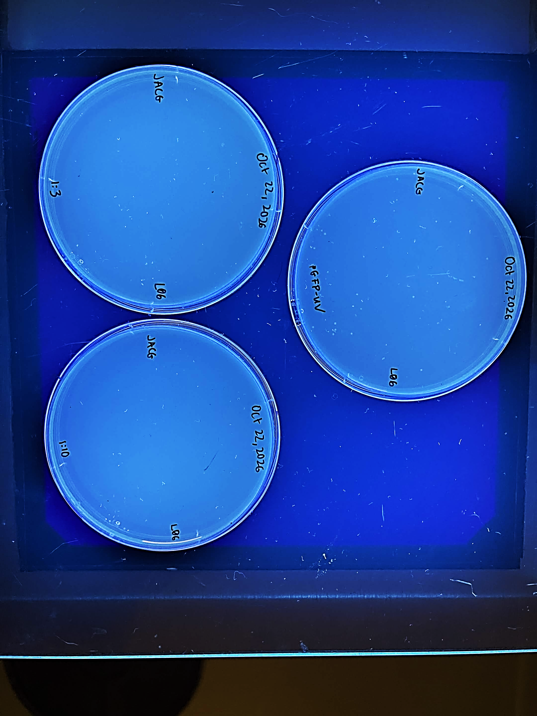
Presence of colonies: Yes, see arrows  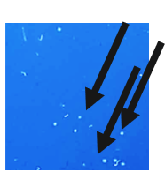 | Presence of colonies: none – the image is dirt and dust  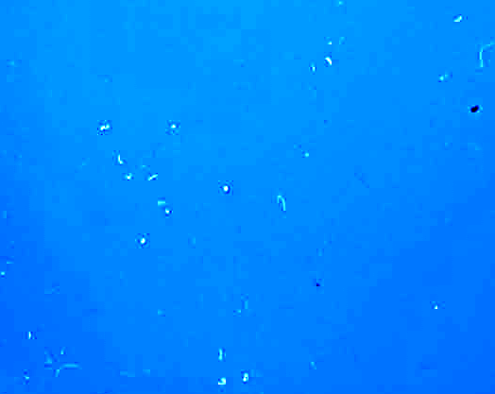 | Presence of colonies: none – the image is dirt and dust  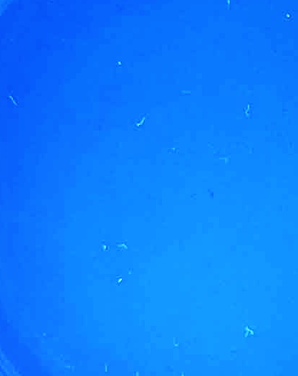
Very bright dots- Likely from GFP fluorescence | Flecks from cracks, and dust, not from colonies. Likely not from GFP and also not from autofluorescence and merely just refraction of light | Flecks from cracks, and dust, not from colonies. Likely not from GFP and also not from autofluorescence and merely just refraction of light

Borrowed from Flora + Eva:
T7 student insert, L06 Thursday room 2022
pGFP-UV | pGFP-S12 + T7 insert 1:3 | pGFP-S12 + T7 insert 1:10
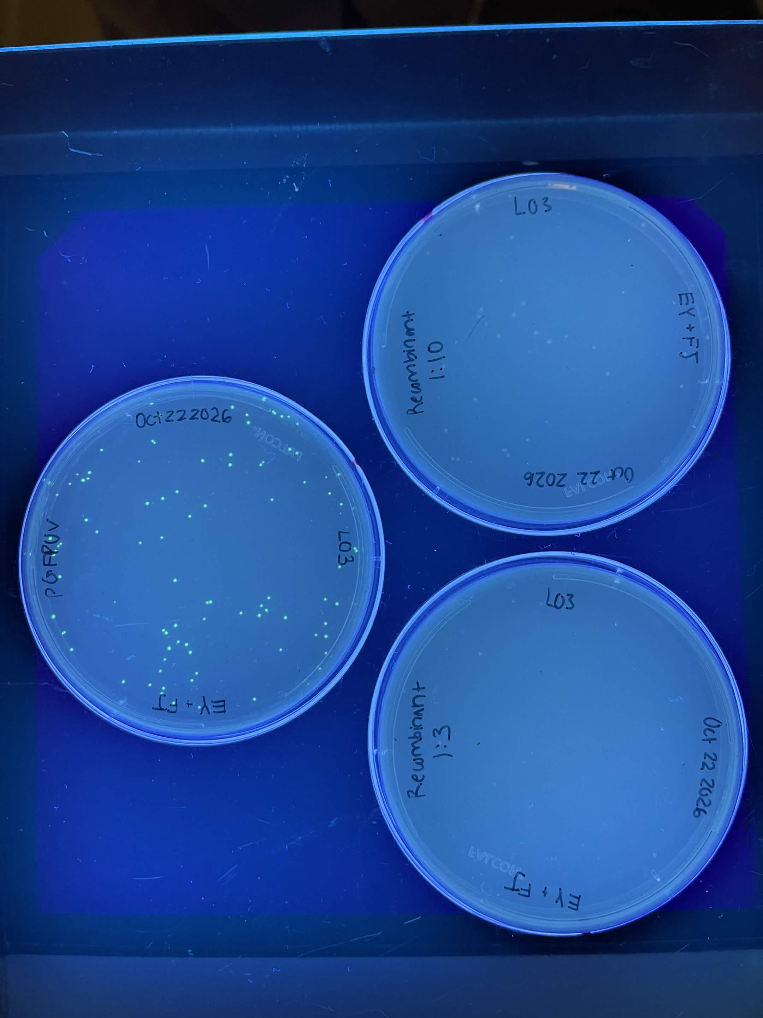
Presence of colonies: Yes, see arrows 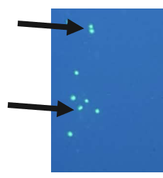 | Presence of colonies: Yes, see arrows  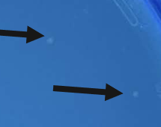 | Presence of colonies: Yes, see arrows  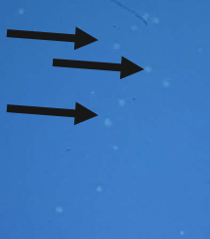
Very bright dots- Likely from GFP fluorescence | Likely from autofluorescence | Likely from autofluorescence

3. Look at both of the no-plasmid control plates, and describe the kind of growth seen in the presence and absence of ampicillin. Note: These results will probably be clearer if you examine the actual plates instead of the images.
L06 Thursday room 2029
Treatment | Competent cells in LB-agar | Competent cells in LB-agar-amp
Visible light close up | 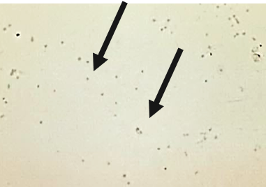 arrows indicate presence of colonies | 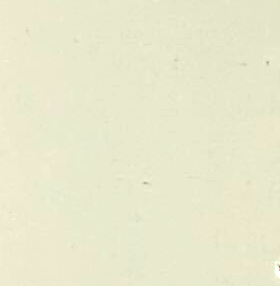
Plate under UV light | 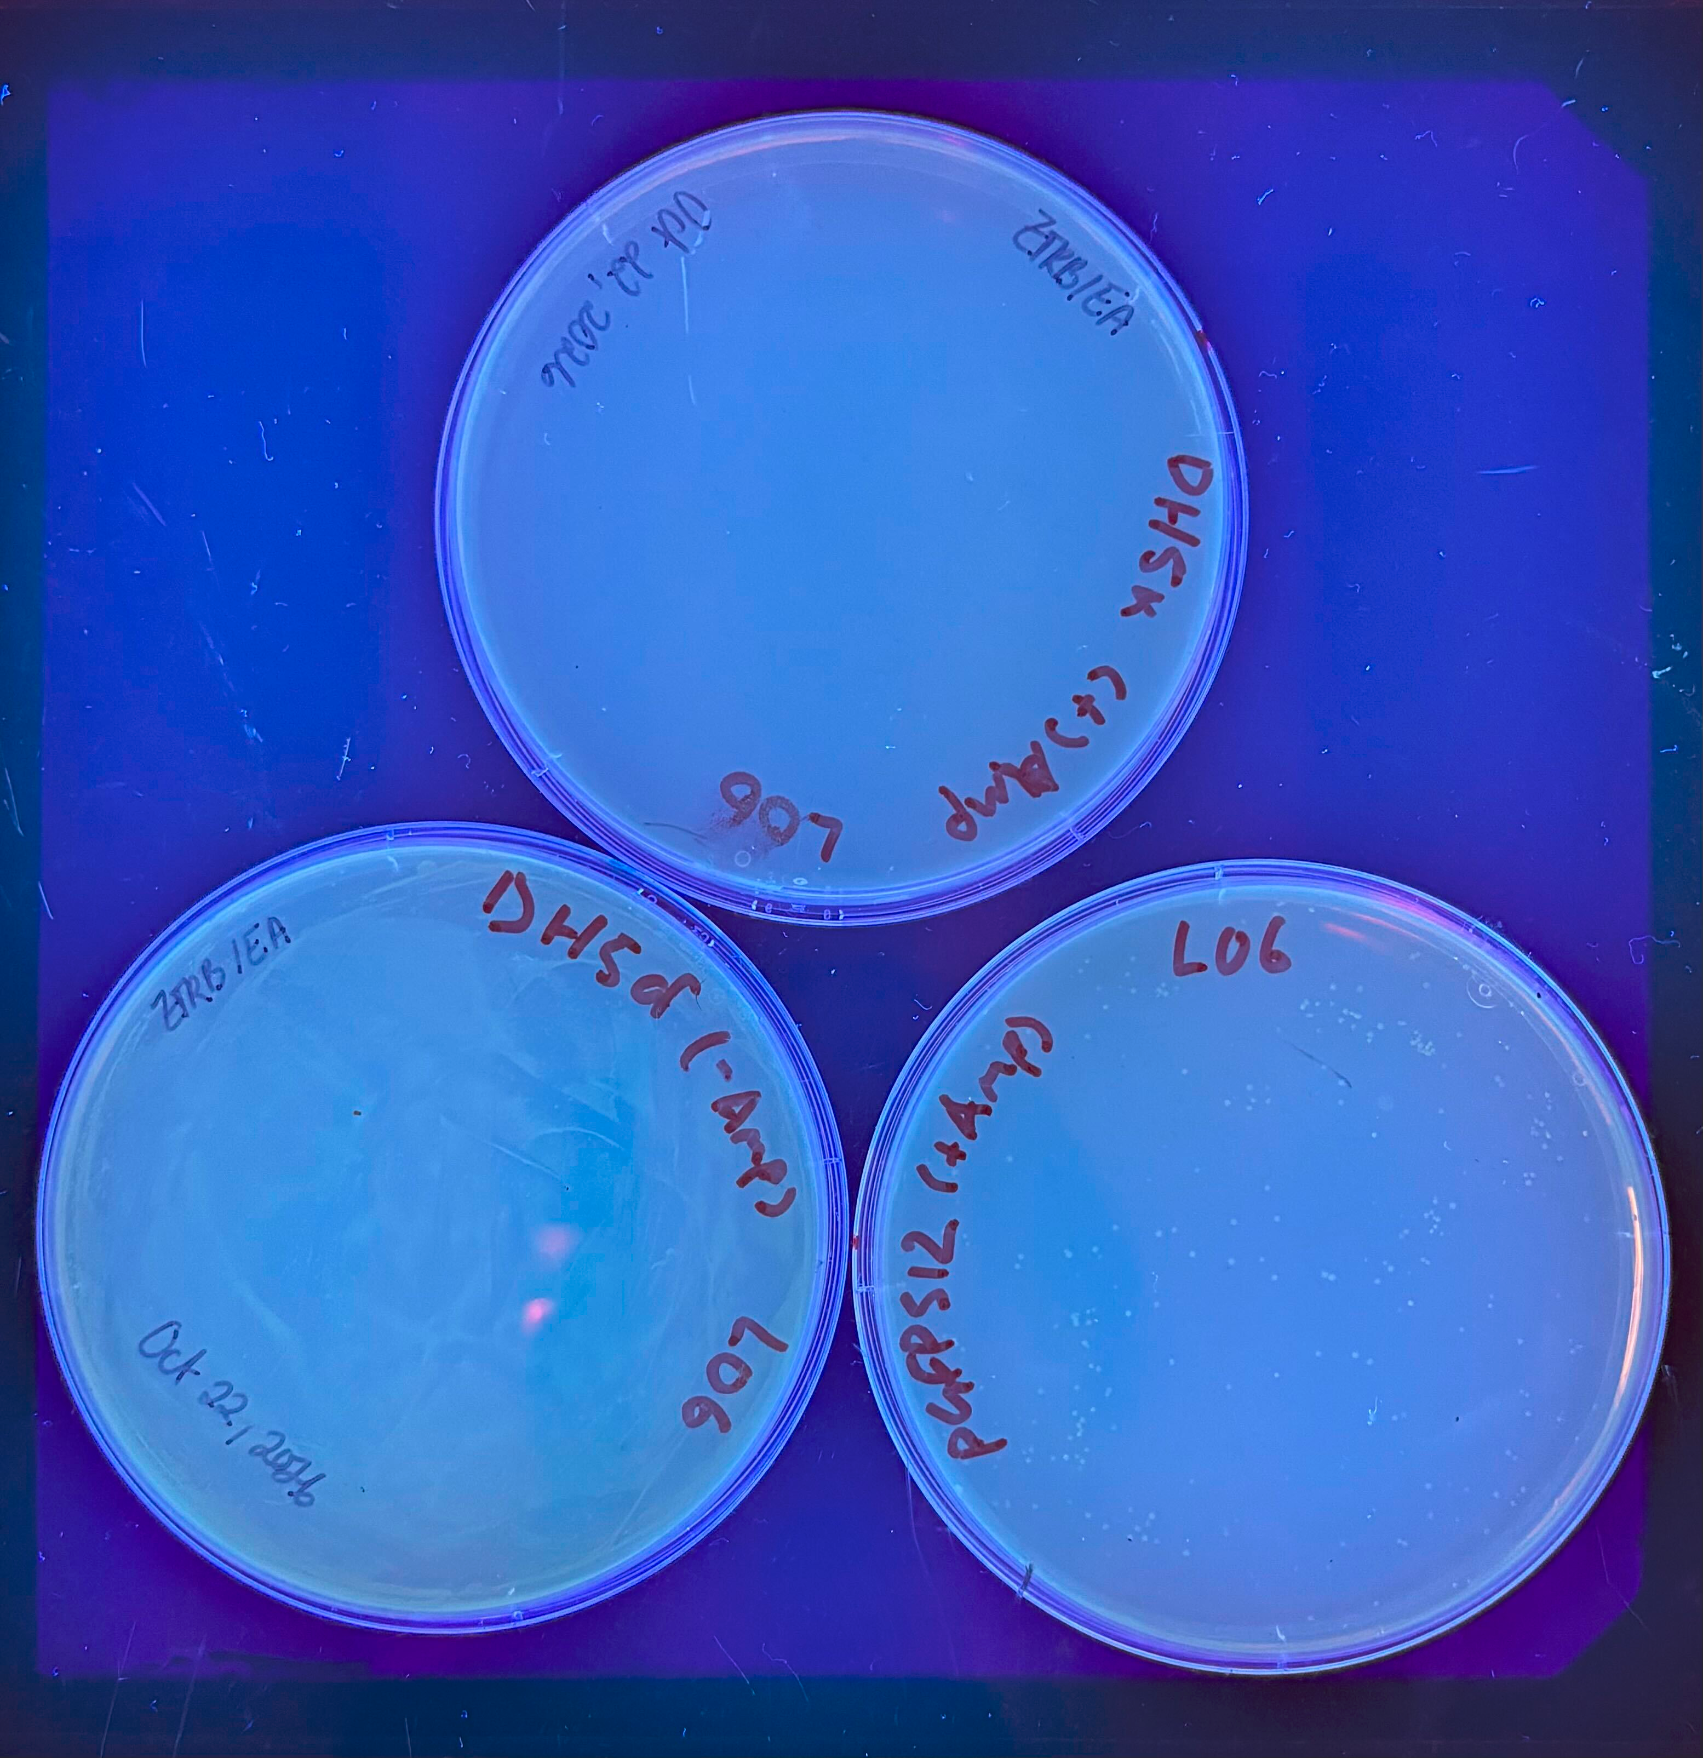
I was able to see growth of colonies in the plate without ampicillin and no colonies in the plate with ampicillin.

4. Do the following to calculate the transformation efficiency of pGFPuv:
(a) Recall how many μg of pGFPuv DNA was used to transform your competent E. coli. Also recall that a volume of media was added to your competent cells after the heat shock procedure, and that 200 μL of this diluted culture was spread on a LB-agar plate. How many μg of the original transforming plasmid DNA does this represent? Show your calculations.
Ug of original transforming plasmid:
(b)How many colonies do you have on your pGFPuv plate? If you have too many colonies to count easily, you may divide your plate into quadrants (or some smaller fraction) and count a single quadrant or fraction. Multiply this count by the number of fractions in order to get an estimate for the entire plate.
14 colonies
(c) What is the number of transformants per μg of pGFPuv DNA? (Divide # of colonies by the μg of original transforming plasmid DNA that was contained in the E. coli cultured on your plate.)
14/

5. Comment on the success of your transformation step based on the outcomes of your pGFPuv control.
- The success of the transformation step was successful in our positive control
-

6. Comment on the success or failure of your ligations based on the outcomes of your ligation plates:
Did the ligation step work, and if so, how do you know? What error might have reduced your success, and what might you try to improve your outcomes?

Lab 8
Purpose: We want to inoculate 4 cultures, using colonies from ligation plates. And then we will miniprep these cultures to extract the plasmid out of them
Expected Outcomes:
- Calculate transformation efficiency.
- Evaluate quality of data based on the success of control samples.
- Set up small scale bacterial cultures and isolate plasmid DNA.
- Use spectrophotometry to quantify plasmid DNA and assess the purity of the DNA samples.
3. Experimental Plan:

4. Big picture:
We need to get cultures that definitely have our transformed plasmid. Then Inoculating our cultures will allow us to grow the transfected E.coli with recombinant DNA so that only our desired plasmid is produced.

Methods:

1. Write down a descriptive title for this week’s experiments and enter this in the Table of Contents.
2. Write a brief introduction to this week’s experiments. Include a clear statement of purpose or
objective (why you are doing it), plus a brief statement of expected outcomes.
3. Describe your experimental plan by drawing a flowchart that outlines all the activities/steps that you
will be doing in this lab. Include estimates of time.
4. Make a note of the methods you will use in this lab. You may either write out these methods or
make note of where the protocols may be found.
5. Explain how your flowchart relates to the Big Picture flowchart (in Lab 1- Introduction) for the
cloning project. In other words, how will these activities help you complete this project?
Screening by restriction analysis
You will need to create a sequence file for your desired recombinant plasmid before you do the
appropriate restriction analysis to screen for the presence of inserted DNA. This will require some
“virtual cloning” of your digested PCR product into the BglII site of pGFP-S12. You may find it helpful
to refer back to the cloning step of your PCR primer assignment (Lab 2) and to your predicted PCR
product for the student primers (Lab 6).
Answer the following questions in your lab notebook. If you do these exercises in a computer file,
you must print them out and paste them in your notebook. Answer all questions so that we can
see your work, and be sure to write/annotate your sequences clearly so that we can
understand what you did

Predict the sequence and structure of the desired recombinant plasmid.
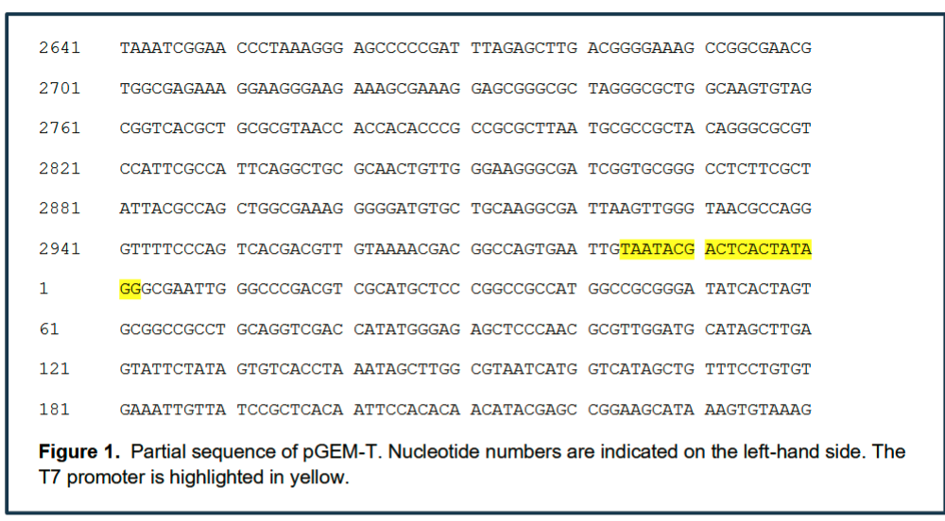
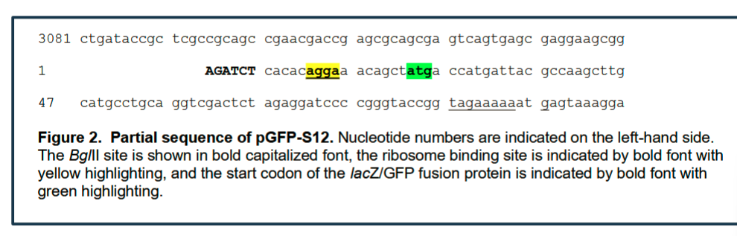
6. You will be analyzing recombinants that have been generated from the following primer
sets. Find their binding sites and note these locations on the partial pGEM-T sequence shown in
Figure 1. (The sequences for the student and instructor primers are shown in Table 1. The restriction
sites on these primers are indicated.)
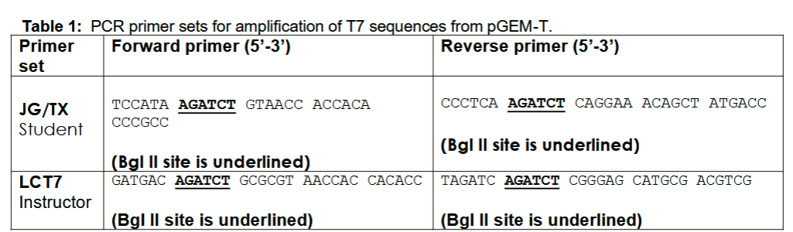

7. Copy out the sequence of your predicted PCR product. (Only the top strand is necessary.) The
partial sequence is shown in Figure 1 for your reference.
8. Virtually digest the ends of this PCR product with the appropriate restriction endonuclease and alter
the sequence accordingly. You may find it helpful to fill in the complementary nucleotides for these
restriction sites in order to figure out where these enzymes will cut within the sequence.
9. Virtually digest the pGFP-S12 sequence with BglII. The partial sequence for this plasmid is shown
in Figure 2.
10. Virtually clone your digested PCR product into the BglII site for pGFP-S12 by inserting the
sequence for your digested product into the sequence of your digested pGFP-S12. Copy the partial
sequence of your desired recombinant—the insert DNA flanked by pGFP-S12 sequence—and
indicate where the DNA would have been ligated together.
11. Download the text file for pGFP-S12 and modify this file to include your insert DNA. The BglII site
(AGATCT) marks the start of this sequence. The modified sequence should resemble your predicted
sequence above—except it will now include the full sequence of the pGFP-S12 backbone. Save this
text file under a new name and make note of it in your lab notes.
Predict the restriction sites and restriction fragment lengths for the desired
recombinant plasmid.
You need to analyze both the original pGFP-S12 and your recombinant plasmid sequences to find
restriction endonucleases that can be used to distinguish between these two plasmids. You may find
it useful to refer back to the initial analyses you did in Labs 1 and 2.
12. Recall the following restriction endonucleases are available for use:
BamHI DraI HindIII NdeI
PstI PvuII(HF) ScaI(HF) XbaI XhoI
Copy Table 2 into your lab notebook, analyze both pGFP-S12 and the recombinant plasmid sequence
using a restriction analysis program of your choice, and fill in the predicted fragment sizes for both
plasmids. Include the sites for all the restriction endonucleases, plus at least one digest that uses two
restriction enzymes.
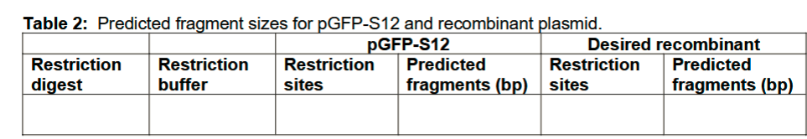

13. Draw or sketch plasmid maps for pGFP-S12 and the recombinant plasmid. Include the restriction
sites for the enzymes you have listed in Table 2 along with the location of these sites (nucleotide
number).
Select a restriction endonuclease to screen your recombinants:
14. Select one restriction digest that will allow you to distinguish easily between the two plasmids.
This is the restriction endonuclease (or endonuclease combination) that you will use to screen your
plasmid preps for the presence of insert DNA.
15. What control(s) will you need to set up in order to be confident of your screening results? What
purpose do these controls serve?
16. Copy Table 3 into your notebook and use it to plan your master mix for the restriction digests.
Plan to digest about 2 μg of plasmid DNA from your preps (or 1 μg of pGFP-S12 stock), and use 5U of
enzyme per digest. It is not necessary to be exact in your amount as long as there is enough DNA to
visualize-- it may be more convenient to pipet the same volume of plasmid in each digest
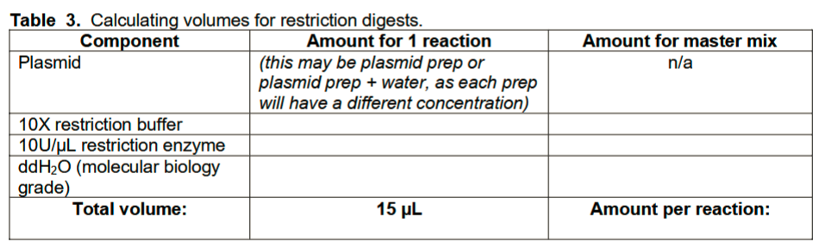

17. We will be confirming the basic structure of these clones through restriction analysis. However,
PCR could also be used to confirm the presence of insert DNA.
(a) If you were to design PCR primers for this purpose, where would you place the forward and
reverse primers?
(b) What kind of result would you expect to see from your primers if you were successful in cloning
the T7 promoter? What if there was no insert? Explain

Have you isolated your plasmid?
1. Refer to your calculations in the pre-lab exercises, and set up your restriction digests to screen
each of your isolated plasmid samples. Set up your control sample(s) as well.
Note: You are only doing 1 set of restriction digests on your plasmids—to select more enzymes and
enzyme combinations could be a waste of resources if a plasmid turned out to be incorrect. Typically,
a more extensive restriction analysis is done on clones that pass this first screening step.
2. Incubate for 1-2 hours at 37°C.
3. Store your digests at -20°C. You will check your digests with gel electrophoresis in the next lab.

